Assignment: Using Ansible to Install and Configure Nginx + Firewall

1. Introduction
Ansible is an open-source automation tool that simplifies IT operations such as configuration management, application
deployment, and orchestration. In this assignment, we will use Ansible to:
- Install Nginx web server on two Ubuntu servers.
- Configure and enable a firewall (UFW).
- Ensure Nginx is accessible on HTTP (port 80).
We will set up one server as the Ansiblehost (server1) and the other as ansibleuser (server2).

2. Environment Setup
- Server1: Ansiblehost ip: 172.31.33.14 (Ansible installed here).
- Server2: Ansibleuser ip: 172.31.35.14 (Nginx will run here).
- Operating System: Ubuntu Server (EC2 instances in AWS).
- Connection: SSH key-based authentication between servers.

3. Step 1: Install Ansible on Control Node
On server1:
sudo apt update
sudo apt install -y ansible
ansible –version - This installs Ansible and verifies the version.
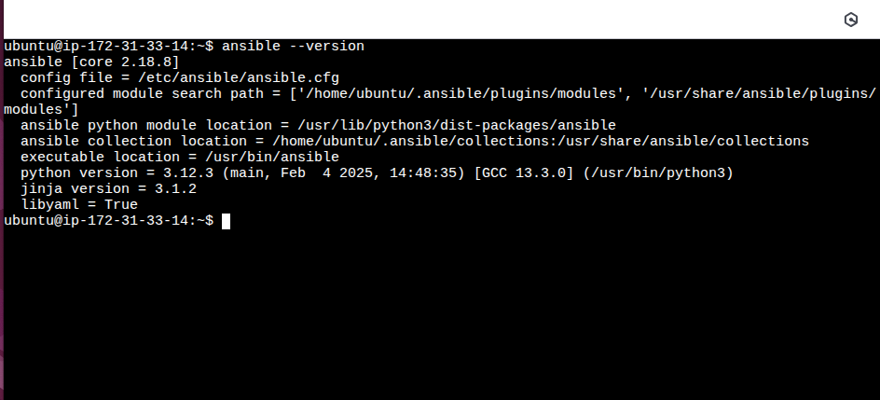

4. Step 2: Configure SSH Access
To manage server2 from server1, we need passwordless SSH login:
- Generate a key pair on server1(ansiblehost) (if not already present):ssh-keygen (Press Enter for defaults).
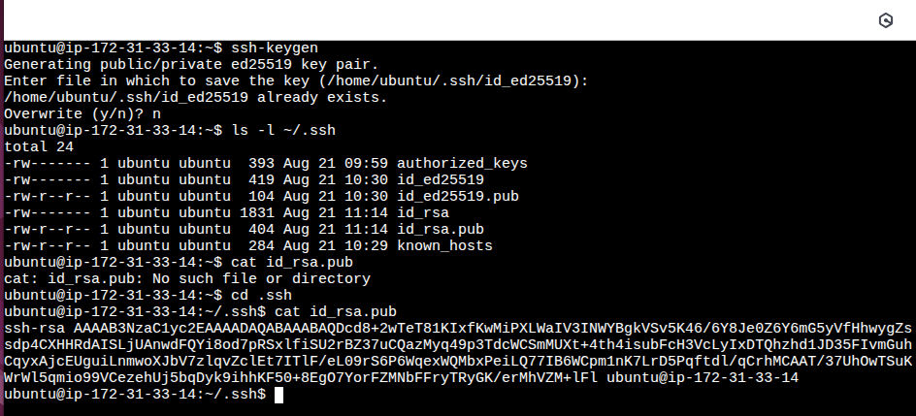
- Copythe public key to server2 in .ssh folder:
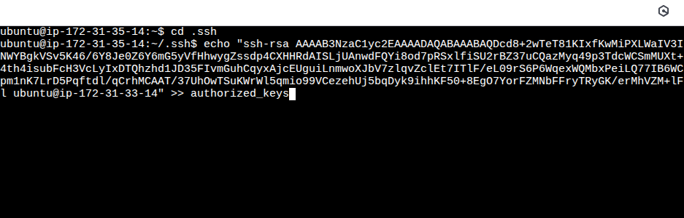
- Test SSH to check the connection establishment:
ssh ubuntu@ip-172-31-35-14
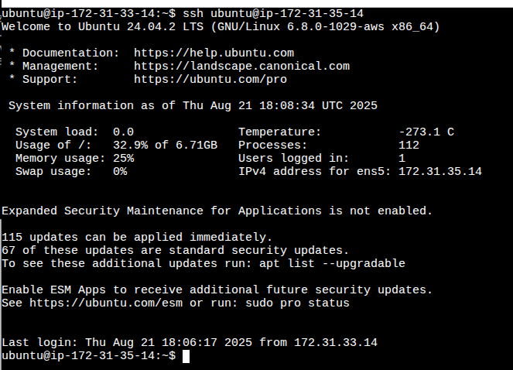

5. Step 3: Create Inventory File
Create a file inventory file on server1(Ansiblehost):
[webservers]
server1 ansible_host=172.31.33.14

- webservers: group of servers we want to configure.
- ansible_host: actual IP of the server.
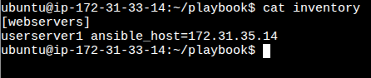

Test inventory with ping: ansible -i inventory.ini all -m ping
Expected output: SUCCESS for each server.
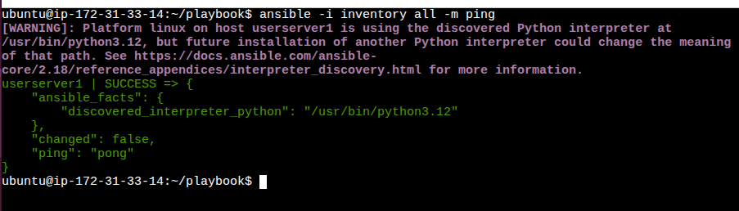

6. Step 4: Write Ansible Playbook
Create a file nginx_install.yml:
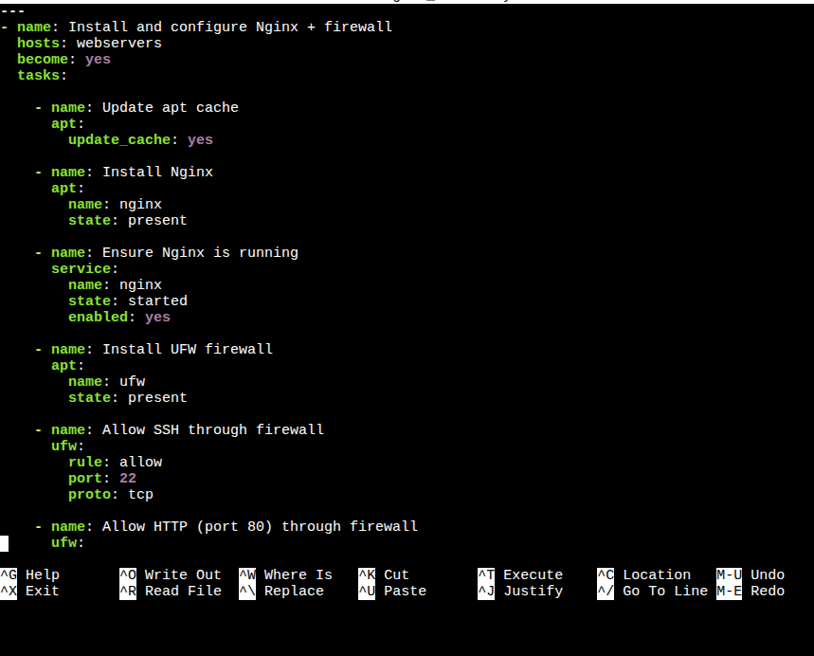

7. Step 5: Run the Playbook
Execute the playbook:
ansible-playbook -i inventory.ini nginx_install.yml
Ansible will:
- Update packages.
- Install and start Nginx.
- Install and enable firewall.
- Allow SSH and HTTP.
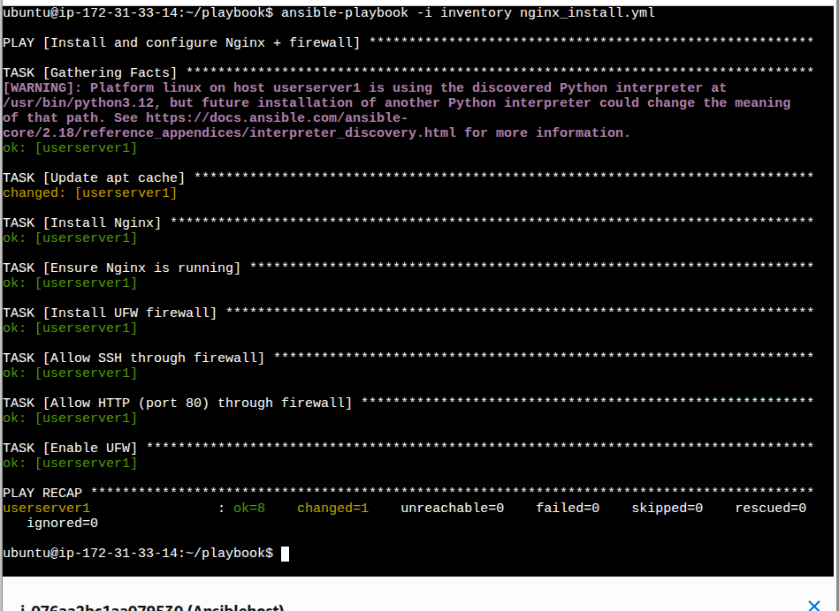

8. Step 6: Verify
On any webserver (server2): Ansibleuser
- Check Nginx service:
systemctl status nginx
- Check firewall rules:
sudo ufw status
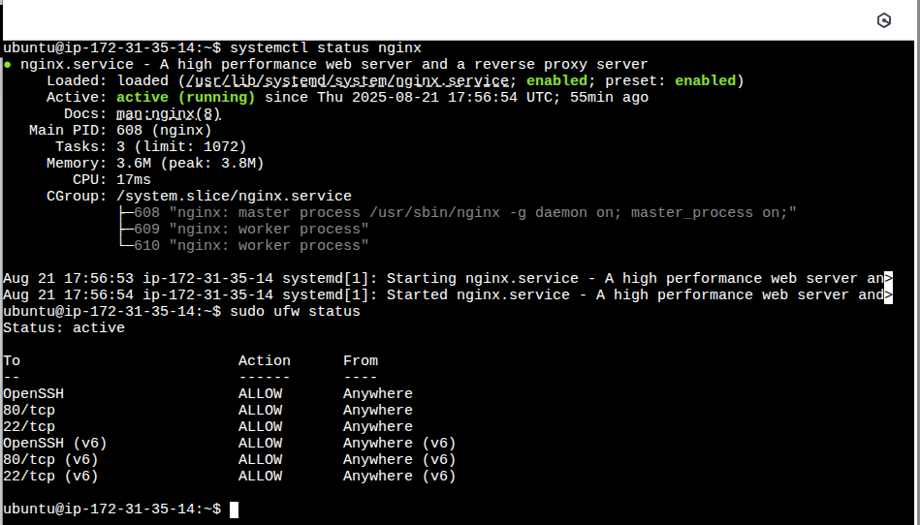
- Visit in browser: to see the Nginx default welcome page.
http://<server-public-ip> - http://13.60.74.145
